Application for COSMOGENIC NUCLIDE Analyses  Helmholtz Laboratory for the Geochemistry  of the Earth Surface, GFZ Potsdam | 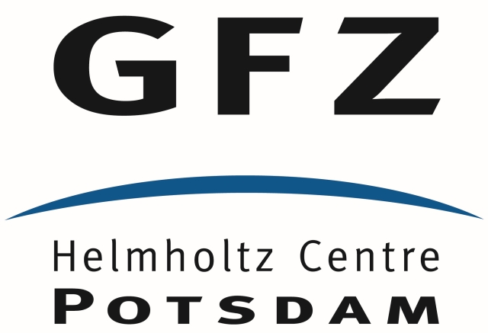

Your name and position
Institute
Contact details (email) |  | Date of application

Thank you for your interest in the Helmholtz Laboratory for the Geochemistry of the Earth Surface (HELGES), GFZ Potsdam. Because our laboratory space and staff capacities are limited, we need to evaluate your application in an internal review process, and therefore kindly ask you to fill this form and provide us with further information about the project, samples and analyses. With your application you acknowledge the current Terms and Conditions. Please take note of the data protection information on the processing of your data before submitting your application (GER / ENG).

We will evaluate your application and make a decision based on the following criteria:
- Innovative scientific potential
- Feasibility (i.e., methods to be used, type of samples, man power involved in performing the work and publishing the results)
- Availability of third-party funding
- Publication record of scientists involved

Project details
Title
Start date |  | End date

Project abstract
Please provide a concise summary about the overall rationale of the study, scientific aims, hypotheses to be tested, origin and type of samples, study areas, and planned analysis.
Optional: You may attach an additional maximum 2 pages with this application that describe the current state of your investigation and/or provide an outline of your future research plan.

Related Research. Please cite the most important publications (by yourself or others):
Describe any current research that is directly related to this proposal:
List of other scientists involved in this project:
Name / position | Institution | e-mail address

☐ Please tick this box if you prefer a fully commercial project
A fully commercial project means that you will supply samples and GFZ staff will perform all sample preparation, analyses, raw data evaluation and reporting of results. The costs can vary, depending on type of analyses, samples type and sample preparation. GFZ will send you a quotation.

☐ Please tick this box if you prefer a collaborative project
A collaborative project means that GFZ scientists will advise on sampling, sample preparation, analysis, data evaluation and interpretation, and will co-author publications. Contributions to costs for analysis/consumables are welcome.

Will the lab work be carried out by a PhD student or postdoctoral researcher? If yes, please provide details in the box below (name, position, and contact details). Elaborate on the practical work/help in the lab that the student/PostDoc will do for the analysis. Important! The student or researcher must either already have all required qualifications or receive training at GFZ before starting the work.

List of peer-reviewed publications (past 5 years) of scientist and/or supervisor who will publish the results

Funding details
For applications that are part of third-party funded projects please indicate source of funding. Please also indicate whether there are funds allocated for analysis costs and/or consumables.

Information about samples and analyses:
☐ in situ ¹⁰Be or ²⁶Al
☐ both in situ ¹⁰Be and ²⁶Al
For either exposure age determination or erosion rate studies. We expect that you estimate the amount of sample that is needed to reach an AMS ¹⁰Be/⁹Be ratio of 10⁻¹⁴. Please indicate if mineral separation is needed (at additional costs), or if pure quartz (<5 mg Al in total sample) is provided.

☐ Meteoric ¹⁰Be
☐ both meteoric ¹⁰Be and ⁹Be
Various applications possible, ranging from dating to denudation rate studies. Please indicate sample type below.
Type of nuclide: ☐ ¹⁰Be ☐ ²⁶Al ☐ ⁹Be (meteoric ¹⁰Be)
Type and origin of samples (applies to meteoric ¹⁰Be):
Description of samples.

☐ rock | ☐ carbonate sediment | ☐ river / spring / ground water
☐ soil | ☐ siliciclastic sediment | ☐ soil water
☐ vegetation | ☐ chemical extractions | ☐ rain water
☐ wood |  | ☐ seawater
☐ other |  | ☐ acid mine drainage

Describe sampling, pre-treatment, storage (e.g., field locations or experimental setup, filtering, acidification, crushing, pulverization and materials with which samples have been in contact during, sampling, preparation, storage (e.g., steel jaw crusher, agate mill, filters, plastic bags or bottles,…), storage conditions (cooled, frozen,..)?

Have samples already been prepared to make them suitable to start processing in the lab? (e.g. soil samples are usually sieved to <2mm; water samples must be filtered and acidified)
How much sample material is available for analyses and do you have appropriate reference materials for calibration and/or quality control (if yes, give names of reference materials)?
Have samples been characterized by other analytical methods (e.g., imaging, chemical composition, mineralogical composition, etc., name relevant information)?
Further sample information / analytical requirements / other relevant information

